Year 11 Physics – NEWTONS 2nd LAW of MOTION
Science Inquiry Skills
Validation Test
Name: | Teacher: | Score /20
Comment:

The following excerpts have been taken from student’s a poorly written lab book.

Hypothesis:

If the mass of an object is changed, then the acceleration of the object will also change

Method
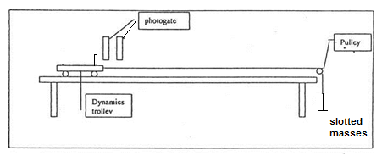
- Set up the trolley with a digital accelerometer as shown in the diagram.
- Record the combined mass of the mass of the trolley and the unknown mass.
- Suspend unknown mass from the pulley. This provides the accelerating force.
- Run the program, release the trolley and record the acceleration.
- Repeat for another two trials before resetting the program
- Add an extra 100 g on the trolley and repeat steps 3-5.
- Repeat the procedure using total additional masses of 200 g, 300g, 400g and 500g on the trolley.

- Quote Newtons 2nd Law of motion.
(2 marks)
- Rewrite the student’s hypothesis so that it is more appropriately stated.
(1 mark)

- What is the independent variable?____________________________________ (1 mark)

- What is the dependent variable? ____________________________________ (1 mark)

- Describe two variables which would need to be controlled in this experiment to make it a fair test.
(2 marks)
The student’s results are presented below.

Table: Mass and acceleration of a motion trolley

Mass on trolley  (g) | Total accelerated mass  (Trolley, + unknown accelerating mass + mass on trolley)  (g) | Acceleration (ms⁻¹)
Mass on trolley  (g) |  | Trial 1 | Trial 2 | Trial 3
0 | 1125 | 4.45 | 4.65 | 4.61
100 | 1225 | 4.2 | 4.15 | 4.25
200 | 1325 | 3.96 | 3.9 | 3.78
300 | 1425 | 3.5 | 3.6 | 3.7
400 | 1525 | 3.5 | 3.2 | 3.41
500 | 1625 | 3.1 | 3.2 | 3.21
600 | 1725 | 2.99 | 2.99 | 2.96

- Process / manipulate the data above to produce results which could be then plotted and interpreted to find the size of the accelerating force and thus the unknown mass.

You have been provided with extra space to right of the table to add any necessary processing of results.

(4 marks)

- Plot your processed data below, and then use the graph to determine: (9 marks)

- the size of the accelerating force
- the mass of the unknown weight.
- the mass of the motion trolley.

To achieve full marks, your answer must include detailed logic and complete workings.
There is space available on the back of this page for calculations.

.

Working cont.

